Computer Language Coding Concepts

Pointer to Pointer Get & Set in a Diagram
The concept of pointer to pointer Get and Set is explained in the article Pointer to Pointer Get & Set. The current article demonstrates its expression in a diagram.

The following system members are part of the system interface of a related item or related list item:

Other Related Item . ID
Other Related Item . Get
Other Related Item . Set
Other Related List Item . ID
Other Related List Item . Get
Other Related List Item . Set

and they are displayed in a diagram as follows:

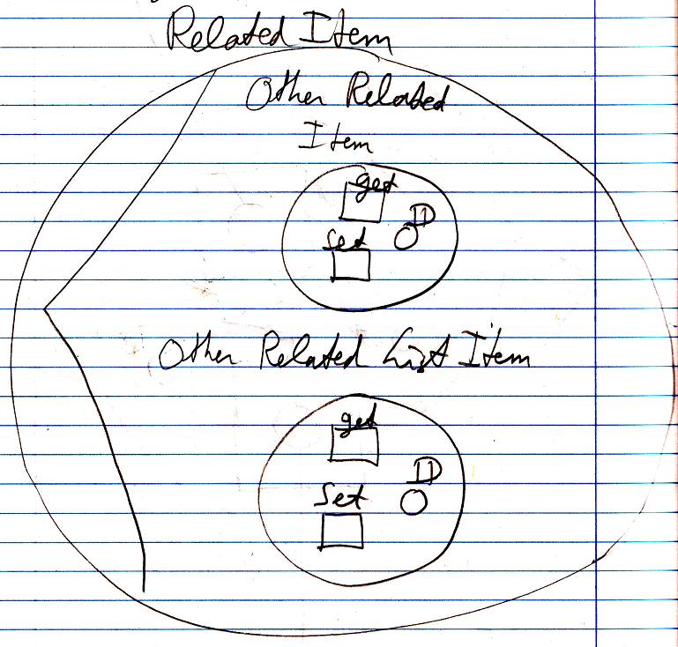

Because the contents of the target object are probably not visible in the diagram, when the system interface is opened, the target of the related item will be connected to the Other Related Item . ID or Other Related List Item . ID of the system interface:

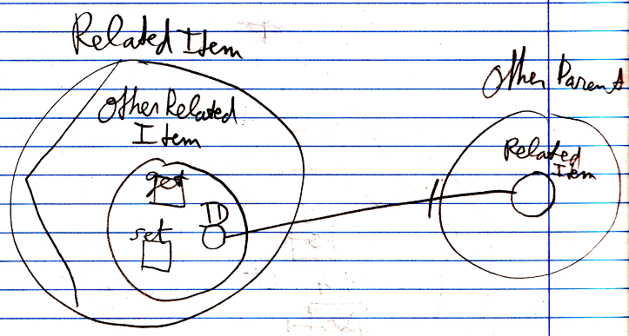

See also: System Objects, Pointer To Pointer Get & Set

Author & Copyright: Jan-Joost van Zon Date: July 18, 2008 – July 23, 2008 Location: Oosterhout, The Netherlands Status: Finished

